***EE2023/TEE2023/EE2023E TUTORIAL 7 (PROBLEMS)***

***Section I : Exercises that are straightforward applications of the concepts covered in class. Please attempt these problems on your own.***



1. Consider the first order system .

(a) Find the unit step response, *ystep*(*t*).

Answer : *ystep*(*t*) = 1 – e-*t*/*τ*

(b) Find the unit impulse response, *yimpulse*(*t*).

Answer :



(c) Verify that and .

(d) Sketch *ystep*(*t*) when *τ* = 1, 2, and -1.

* At what time does the step responses reach 63.2% of their final values?

Answer : *t* = 1 when *τ* = 1 and *t* = 2 when *τ* = 2

* Where does the system pole lie and what is the relationship between pole location and transient behaviour?

2. Consider a second order system with a

* steady-state gain of 0.75,
* damping ratio of 0.6, and
* undamped natural frequency of 2.

Representing the input signal as *f*(*t*), derive an expression for the convolution integral representing the output signal of the second order system.



Answer :

***Section II : Problems that will be discussed in class.***

1. The responses of four first-order systems, labelled from (i) to (iv), when unit impulses are applied at *t* = 0 are shown in Figure 1.

(a) Sketch the corresponding unit step responses. Each plot should be clearly labelled as (i), (ii), (iii) or (iv).

(b) Mark the locations of the poles for each system on the s-plane. Numerical values of the poles need not be given but their relative positions must be clear.

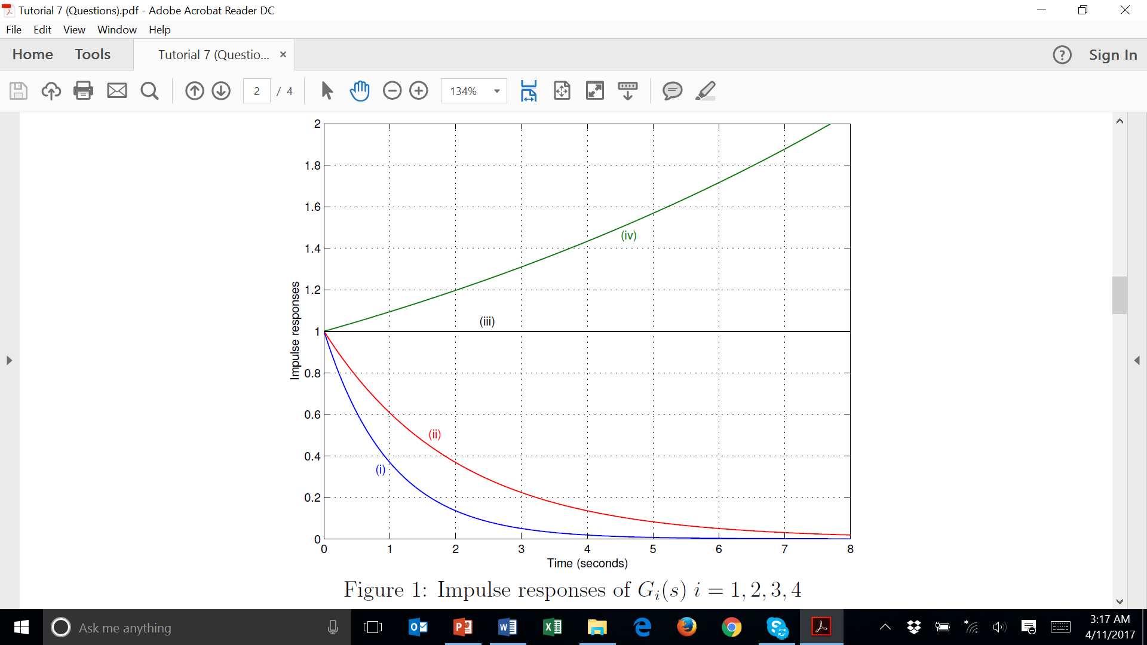

2. The step/impulse responses of four processes are shown in Figure 2. Assume that the step/impulse signal is introduced at *t* = 0 and the transfer function of all the systems assume the following form



Determine the parameters *A*; *a*; *b*; *c* and *L* for all four systems *Gi*(*s*) ; *i* = 1; 2; 3; 4.



Answer :

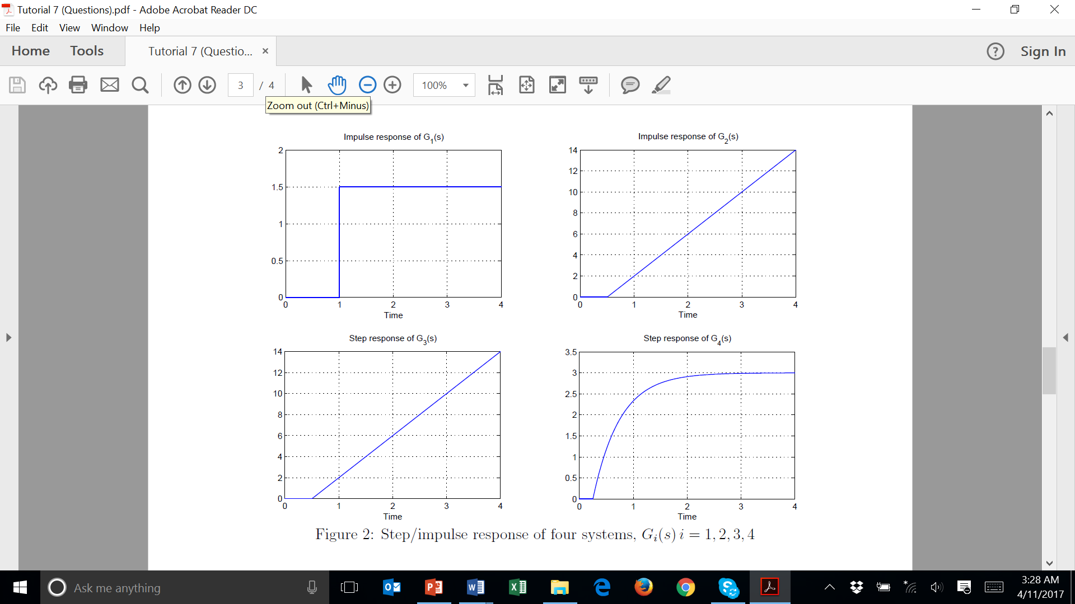

3. A system may be modeled by the transfer function



Suppose the unit step response of the system is



(a) Determine the system poles. Answer : *s* = -15.1, ±1.31*j*

(b) Derive the value of *A*. Answer : *A* = 6.1

4. Suppose a digital thermometer used to measure body temperature is a first-order system,



, with unity steady state gain.

1. Find the time constant, *τ* , of the thermometer, given that a unit step change in the body temperature causes the reading of the digital thermometer to change at the rate of 0.025oC/sec initially, i.e. $\frac{d}{dt}y_{step}\left(0\right)={0.025}^{o}\text{C/sec}$ where *ystep*(*t*) is the unit step response of the thermometer.

Answer : 40

1. How much time is needed for the thermometer to indicate 99% of the steady-state value if the input is a unit step function?

Answer : 184.2

***Section III : Practice Problems. These problems will not be discussed in class.***

1. A car suspension system and a very simplified version of the system are shown in Figure 3(a) and 3(b) respectively.

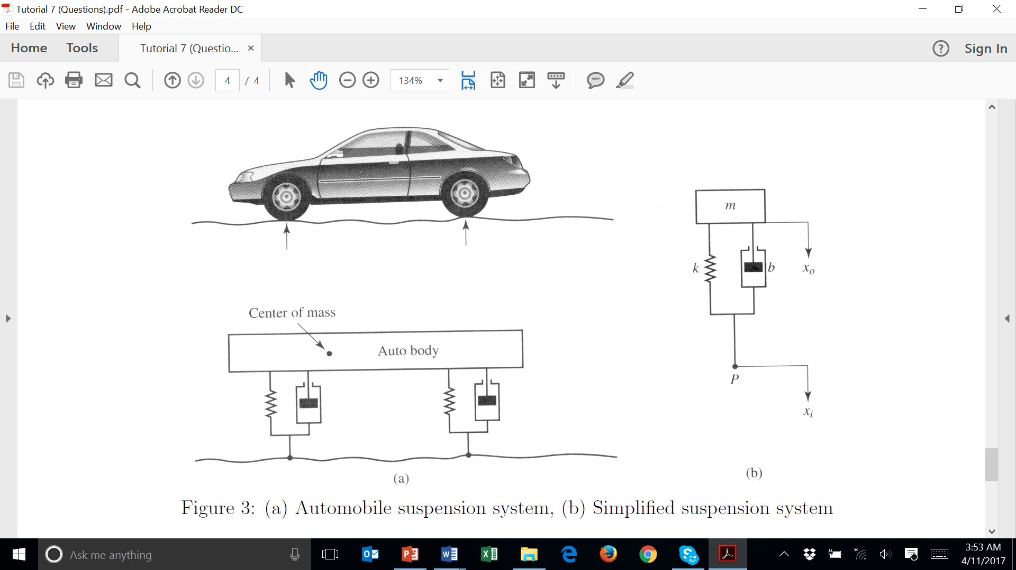

The differential equation relating the height of the car, , to the wheels position, , is



**Suppose the car is traveling over smooth, level ground and it hits a curb of unit height at *t* = 0 i.e. *xi*(*t*) = *u*(*t*). Find the vehicle height, *xo*(*t*), for *t* ≥ 0, assuming that *m* = 1, *k* = 2, *b* = 3,



Answer :

2. The unit step response of is . Using the unit step response of



, derive the unit step response of .



Answer :